White Box Testing

1. Log In and Sign Up

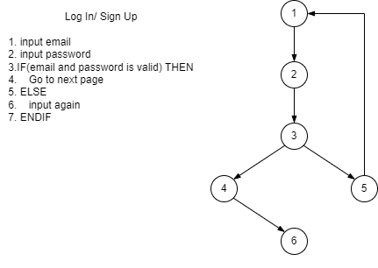

V(G) = number of edge – number of node + 2 = 6 – 6+2 =2

Path1: 1 2 3 4 6

Path2: 1 2 3 5 1

Input: Email and password

Condition:

Email must be a valid email and password must be at least 6 characters.

Test Case:

1. Email and password is correct
2. Email is not valid but password is correct
3. Email is valid but password is wrong
4. Email is valid but password is less than 6 characters
5. Email and password are empty space.
6. Email is the already in use (for Sign Up)

|  |  |  |  |  |  |
| --- | --- | --- | --- | --- | --- |
| Test ID | Email | Password | Expected Result | Actual Result | Accepted Result |
| 1 | [test@gmail.com](mailto:test@gmail.com) | 123456 | Pass | Pass | Pass |
| 2 | test | 123456 | Fail | Fail | Pass |
| 3 | [test@gmail.com](mailto:test@gmail.com) | 234567 | Fail | Fail | Pass |
| 4 | [test@gmail.com](mailto:test@gmail.com) | 123 | Fail | Fail | Pass |
| 5 |  |  | Fail | Fail | Pass |
| 6 | [test@gmail.com](mailto:test@gmail.com) | 123456 | Fail + alert message | Fail + alert message | Pass |

1. Collect user information

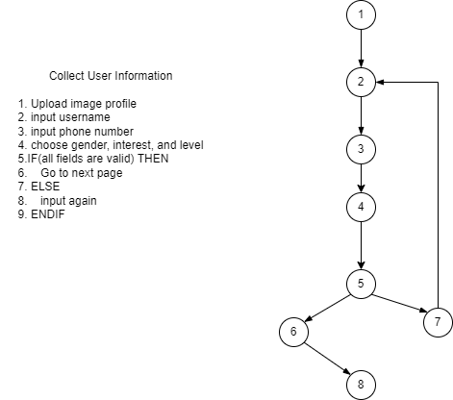

V(G) = number of edge – number of node + 2 = 8 – 8+2 =2

Path1: 1 2 3 4 5 6 8

Path2: 1 2 3 4 5 7 2

Input:

Image file, Username, phone number, others selectable fields (gender, interest, level, height, weight, date of birth)

Condition:

Username cannot be empty.

Phone number must be 10 digits.

Gender and level cannot be empty.

Test Case:

1. All field are correct
2. Image file that upload is not an image (ex: .pdf, .xlsx….)
3. Image file is not selected.
4. Username is empty.
5. Username is a number
6. Phone number is less than 10 digits.
7. Phone number is not a number.
8. Gender is not selected
9. Level is not selected
10. At least one of interest, height, weight and date of birth fields are not selected.

|  |  |  |  |  |  |  |  |
| --- | --- | --- | --- | --- | --- | --- | --- |
| Test ID | Image File | Username | Phone Number | Other Selectable Fields | Expected Result | Actual Result | Accepted Result |
| 1 | profile.png | test | 0942504041 | Pass | Pass | Pass | Pass |
| 2 | profile.pdf | test | 0942504041 | Pass | Fail | Pass | Fail |
| 3 |  | test | 0942504041 | Pass | Fail | Fail | Pass |
| 4 | profile.png |  | 0942504041 | Pass | Fail | Fail | Pass |
| 5 | profile.png | 123 | 0942504041 | Pass | Pass | Pass | Pass |
| 6 | profile.png | test | 12345 | Pass | Fail | Fail | Pass |
| 7 | profile.png | test | abcde | Pass | Fail | Fail | Pass |
| 8 | profile.png | test | 0942504041 | Gender is empty | Fail | Fail | Pass |
| 9 | profile.png | test | 0942504041 | Level is empty | Fail | Fail | Pass |
| 10 | profile.png | test | 0942504041 | Other fields is empty | Pass | Pass | Pass |

1. Add New Video to the system

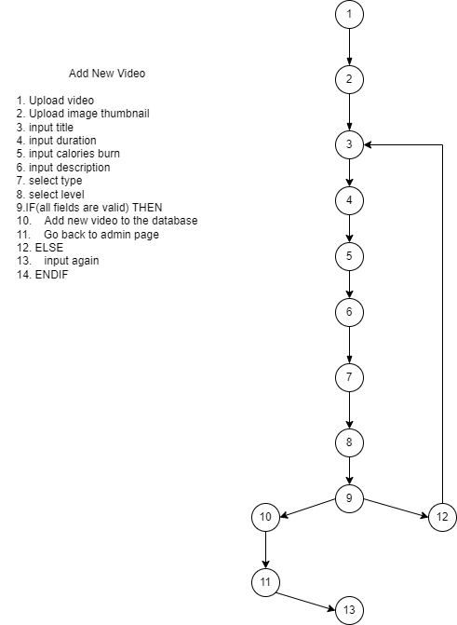

V(G) = number of edge – number of node + 2

= 13 – 13 + 2 =2

Path1: 1 2 3 4 5 6 7 8 9 10 11 13

Path2: 1 2 3 4 5 6 7 8 9 12 3

Input:

Video file, image file, title, duration, calories burn, description, type, level

Condition:

Each fields cannot be empty.

Duration(minute) and calories burn must be a positive number.

Test Case:

1. All field are correct.
2. Video file that upload is not a video (ex: .pdf, .xlsx….)
3. Video file is not selected.
4. Image file that upload is not an image (ex: .pdf, .xlsx….)
5. Image file is not selected.
6. title is empty.
7. title is a number
8. duration is empty.
9. duration is not a number.
10. calories burn is empty.
11. calories burn is not a number.
12. Description is empty.
13. Type is not selected
14. Level is not selected

|  |  |  |  |  |  |  |  |  |  |  |  |
| --- | --- | --- | --- | --- | --- | --- | --- | --- | --- | --- | --- |
| Test ID | video file | image file | title | duration | calories burn | description | type | level | Expected Result | Actual Result | Accepted Result |
| 1 | video.mp4 | image.png | test | 10 | 100 | Test upload | Yoga | Easy | Pass | Pass | Pass |
| 2 | video.pdf | image.png | test | 10 | 100 | Test upload | Yoga | Easy | Fail | Pass | Fail |
| 3 |  | image.png | test | 10 | 100 | Test upload | Yoga | Easy | Fail | Fail | Pass |
| 4 | video.mp4 | image.pdf | test | 10 | 100 | Test upload | Yoga | Easy | Fail | Pass | Fail |
| 5 | video.mp4 |  | test | 10 | 100 | Test upload | Yoga | Easy | Fail | Fail | Pass |
| 6 | video.mp4 | image.png |  | 10 | 100 | Test upload | Yoga | Easy | Fail | Fail | Pass |
| 7 | video.mp4 | image.png | 123 | 10 | 100 | Test upload | Yoga | Easy | Pass | Pass | Pass |
| 8 | video.mp4 | image.png | test |  | 100 | Test upload | Yoga | Easy | Fail | Fail | Pass |
| 9 | video.mp4 | image.png | test | abc | 100 | Test upload | Yoga | Easy | Fail | Fail | Pass |
| 10 | video.mp4 | image.png | test | 10 |  | Test upload | Yoga | Easy | Fail | Fail | Pass |
| 11 | video.mp4 | image.png | test | 10 | abc | Test upload | Yoga | Easy | Fail | Fail | Pass |
| 12 | video.mp4 | image.png | test | 10 | 100 |  | Yoga | Easy | Fail | Fail | Pass |
| 13 | video.mp4 | image.png | test | 10 | 100 | Test upload |  | Easy | Fail | Fail | Pass |
| 14 | video.mp4 | image.png | test | 10 | 100 | Test upload | Yoga |  | Fail | Fail | Pass |